|  |  |
| --- | --- |
|  | Software Requirements Specification (SRS) |
|  |  |
|  | VAIBHAVI D. WARKE  Pimpri Chinchwad College of Engineering, Pune  10/1/20 |

**INDEX**

|  |  |
| --- | --- |
| **Chapter** | **Contents** |
| 1. | **Introduction**  1.1 Purpose of application  1.2 Objectives of the application  1.3 Scope of the application |
| 2. | **Overall Description**  2.1 Application Perspective  2.2 Application Features  2.3 User classes and Characteristics  2.4 Assumptions and dependencies |
| 3. | **System Features**  3.1 System specification  i. System Design  ii. Hardware  iii. Software  3.2 Functional requirements  3.3 Non-functional requirements |
| 4. | **Future Scope** |

**Chapter 1: Introduction**

# Purpose

# The purpose of the application on Online Shopping System is to manage details of shopping, Product, Payment and Customer. It tries to enhance access to care and improve the continuity and efficiency of services.

# Objectives of Application

# **To provide an interactive interface to customers to make shopping and payment**more comfortable**.**

# To provide a standard interface for the buyers

# To create an interface having a facility to accept the orders 24*7

# To enable customers, enjoy easy shopping from anywhere.

# Scope of Application

# The current system allows the users to create accounts and save products in to wish list.

# The customer can login or register to this system.

# He can also browse the products catalogue

# In the current system, customer can add products to the cart.

# The current system is confined only to the shopping cart process.

**Chapter 2: Overall Description**

1. **Application Perspective**

This product is designed to run an any system that is capable of running a web browser. The sole requirement for the user is a web browser most preferably chrome.

1. **Application Features**

* The Online Shopping System Interface is targeted to the **future shopping solution** for the users who can buy the products online anytime and from anywhere.
* Acts as a standard interface between the customers and suppliers.

1. **User classes and Characteristics**
2. **Customer**

This module describes all about customers, by using this module any customer can do some operations like create a new account, browse the product catalogue, add products to the wish list and customer can also remove products from wish list if he wishes to. This module consists following functionalities.

* **Create New Account**: User can create a new account by providing his personal details.
* **Browse the product catalogue:** Customer can browse the products catalogue to make the shopping.
* **Add products to cart**: Customer can add products to the cart so that he can purchase that product.
* **Remove products from the cart**: Customer can remove the products from the cart if he wishes.
* **Make payments:** customer can purchase the products by making payments.

1. **Assumptions and dependencies**

* It is assumed that a computer has a web browser installed on the OS. Website must have enabled cookies.
* Supplier have the products available to deliver them to the customer.
* Also, we are assuming that the supplier has all the customer details required to deliver the product beforehand.

**Chapter 3: System Features**

* 1. **System Features**

1. **System Design**
   * 1. 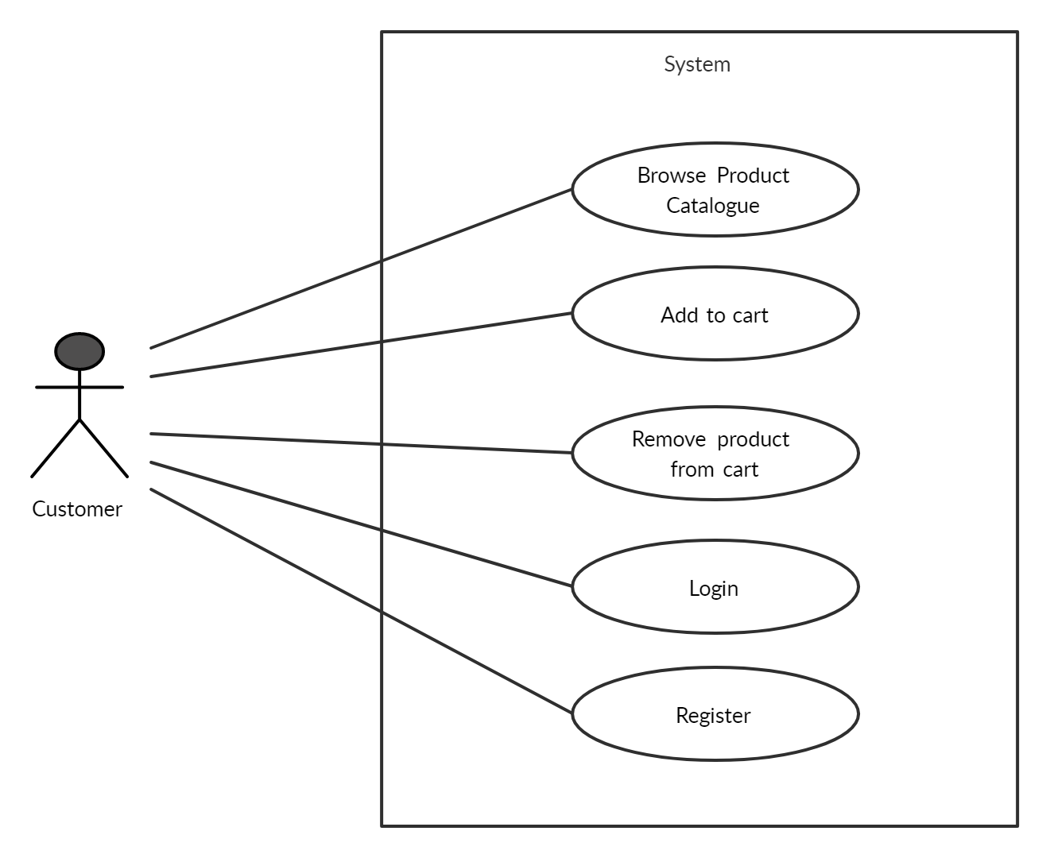**Use case diagram**
     2. 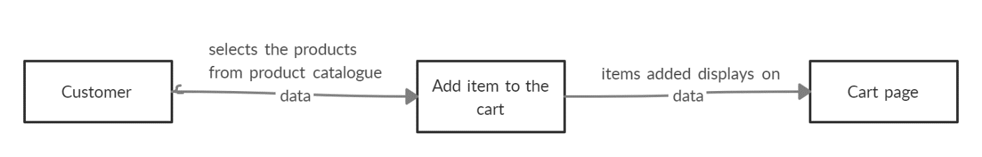**Data flow diagram**
     3. **ER diagram**

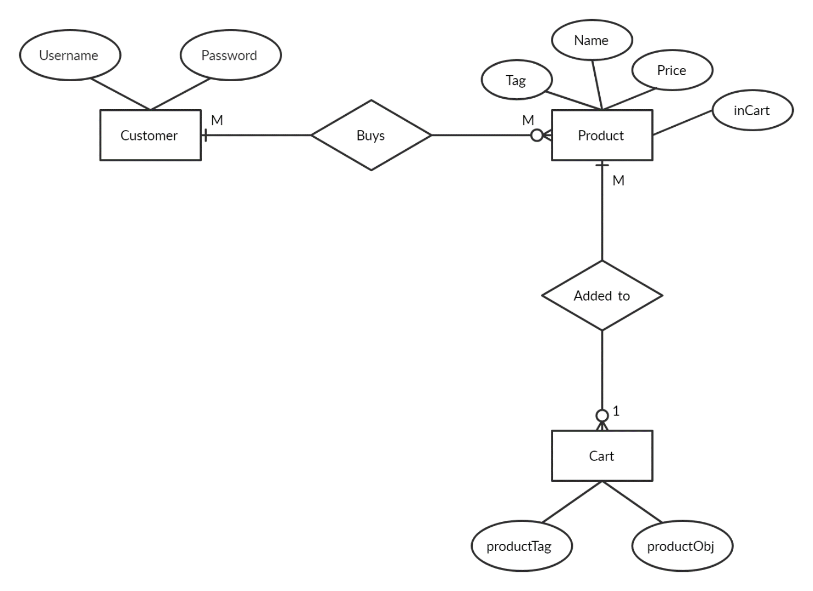

* + 1. 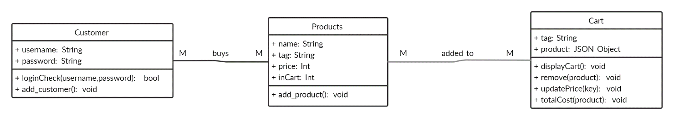**Class diagram**
    2. **Sequence Diagram**

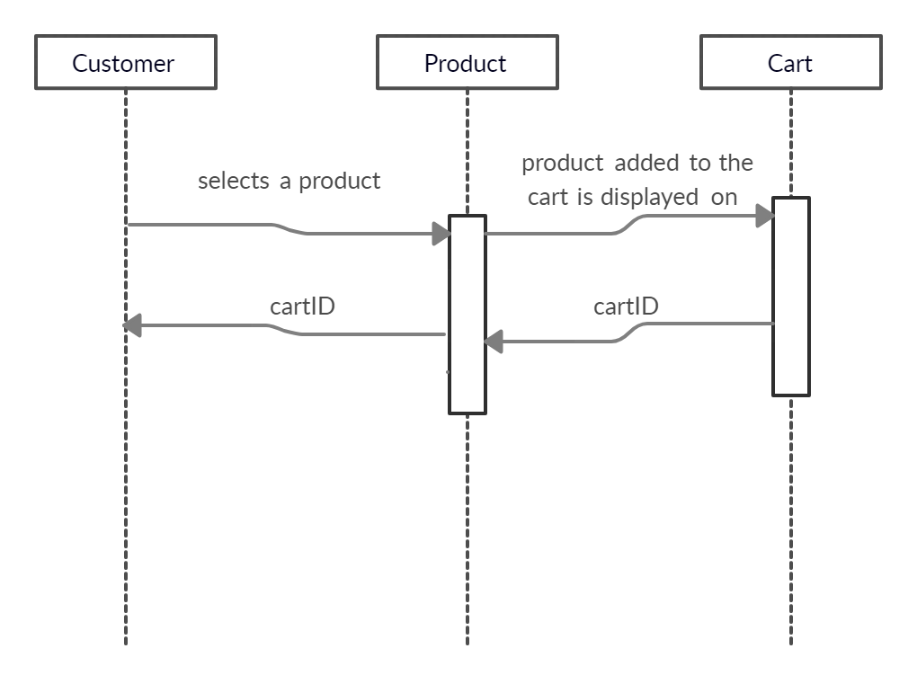

1. **Hardware**

* **Hardware**: Pentium based systems with a minimum of P4
* **RAM**: 256MB (minimum)
* **HTML Designing**: Visual Studio Code
* **Web Browser**: Chrome

1. **Software**

* **Web Technologies:** HTML, JavaScript, CSS
  1. **Functional requirements**

1. **Home page:** The main page contains the featured products and exclusive products on the page.
2. **Login/Register page:** In this page, customer can login or register to the online shopping system.
3. **Products catalogue page:** In this page, customer can browse the catalogue having multiple products. He also can add the products to the cart from this page.
4. **View cart page:** Here, customer can view the products added to the cart along with the product details and total price.
5. **Checkout page:** Customercan check out the products added to the cart and proceed to payment using this page.
6. **Payment successful page:** After successful payment, customer will see this page.

* 1. **Non-functional requirements**

1. **Performance**

The application should be able to interface with existing system. It should be accurate. The existing system is completely dependent on the user to perform all the duties.

1. **Availability:**

The system should be available at all times. Customer can access it through the web browser.

1. **Maintainability:**

The system should be easy to maintain or update the website.

1. **Portability:**

The application is HTML, CSS and JavaScript based. So, the end-user part is portable and any system using the browser should be able to do all the functionalities or features available.

1. **Usability:**

The application is designed for user-friendly environment and ease of use.

**Chapter 4: Future Scope**

# This application can be transformed into an android app. So that it will be get easily available to all customers for online shopping. Also, this application can have a supplier module to manage the product catalogue. To add more products or to check the availability of quantity of the product we need supplier’s module. We can also have an admin module which will manage all the suppliers as well as products.